**MATLAB Project #1**

**Date Submitted: March 4, 2014**

**Group 3:**

Daniel Noyse  
Brandyn Fastino

Cullen Fahey

Jenny Doan

ECE 321

Continuous Time Linear Systems

Karen Payton

Spring 2014

Table of Contents

Introduction 3

Tables 3

Plots 4

Part 1: 4

Part 2: 7

Part 3: 10

Answers to the Questions 11

Write a mathematical expression for the melody in Part 1. Your answer should be written as an algebraic combination of unit steps and sinusoids and take into account both rests and pauses. 11

Describe the ways in which the spectrogram of the reverberant melody in Part 3 differs from the original melody in Part 1. Specifically discuss effects of the amplitude and reverberation modifications you made on the spectrogram. 11

Describe how the modifications in Parts 2 and 3 changed the way the melody sounded. Relate the differences you hear to the amplitude and reverberation modifications you made. 11

Conclusion 11

# Introduction

[Section by Brandyn Fastino]

The first Matlab project of this class required our group to be given a task to make a melody. Specifically it was Ludwig van Beethoven 5th symphony in C-minor. This project was broken up into several parts. The first part required us to generate the melody, which was only a small section of the symphony. The second part was to improve the quality of the melody. The final section required the group to create reverberation, which creates an echo environment.

# Tables

[Section by Jenny Doan]

Table 1: Note's Frequency

Table 3: Time Segment Durations

|  |  |
| --- | --- |
| **Segment** | **Duration** |
| Attack | 0.06s |
| Decay | 0.03s |
| Sustain | 0.5s |
| Release | 0.03s |

Table 2: Note Rest Duration

|  |  |
| --- | --- |
| Note/Rest | Duration in Sec |
| Whole | 2 |
| Half | 1 |
| Quarter | 0.5 |
| Eighth | 0.25 |
| Sixteenth | 0.125 |

|  |  |
| --- | --- |
| Notes | Frequency (Hz) |
| A(low) | 220.00 |
| A#,Bb | 233.08 |
| B | 246.94 |
| C | 261.63 |
| C#,Db | 277.18 |
| D | 293.66 |
| D#,Eb | 311.13 |
| E | 329.63 |
| F | 349.23 |
| F#,Gb | 369.99 |
| G | 392.00 |
| G#,Ab | 415.30 |
| A(High) | 440.00 |

# Plots

[Section by Jenny Doan]

## Part 1:

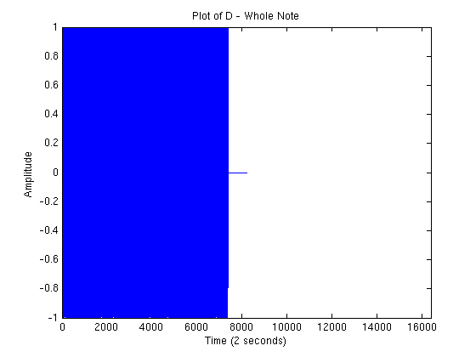

Figure

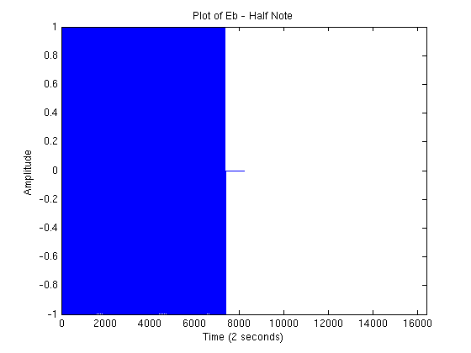

Figure

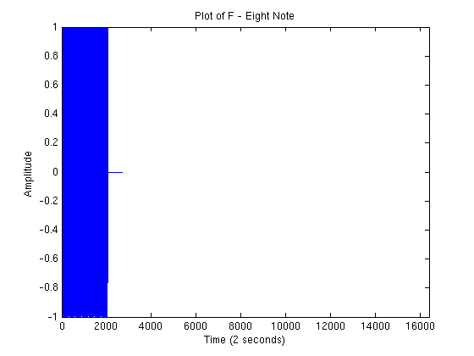

Figure

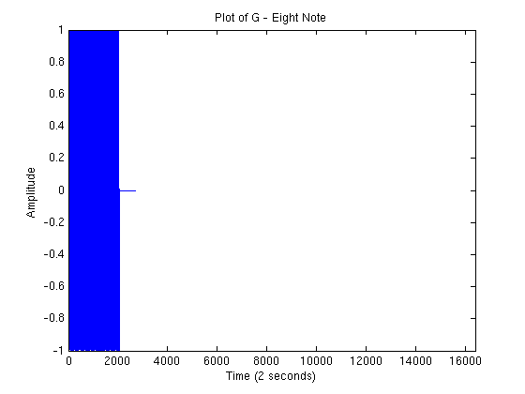

Figure

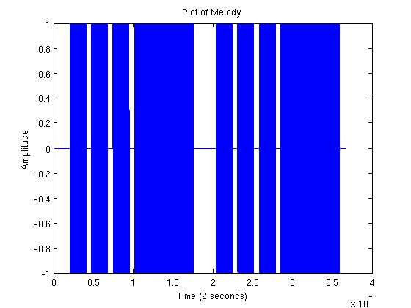

Figure

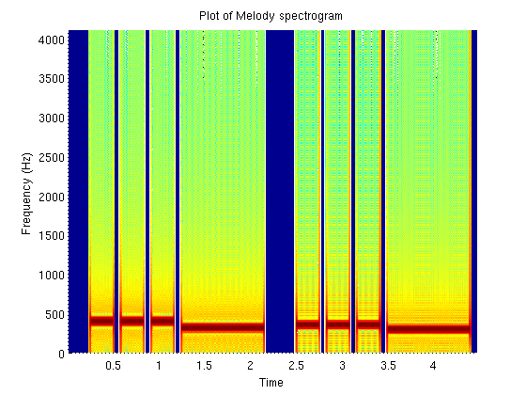

Figure

## Part 2:

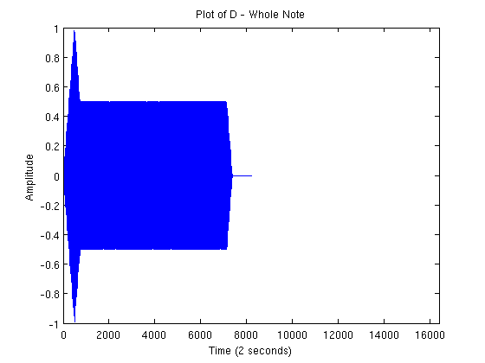

Figure

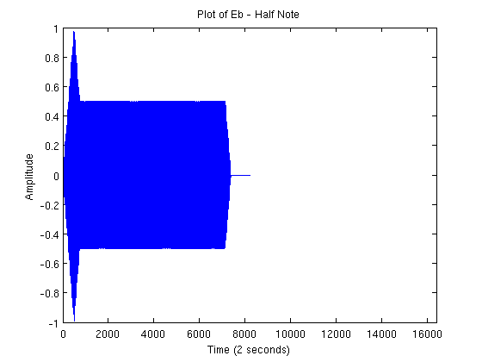

Figure

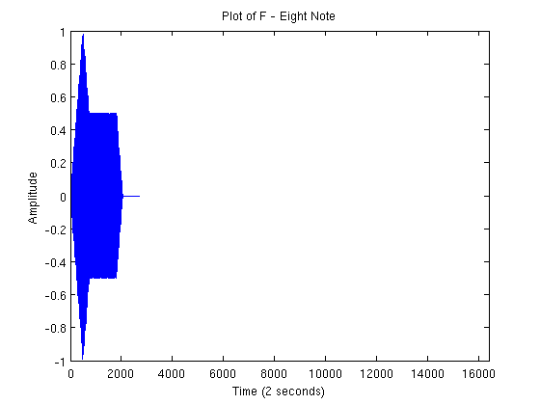

Figure

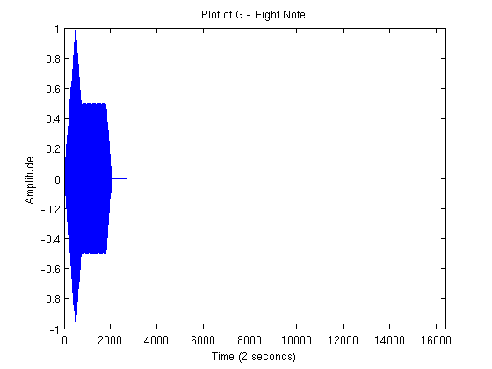

Figure

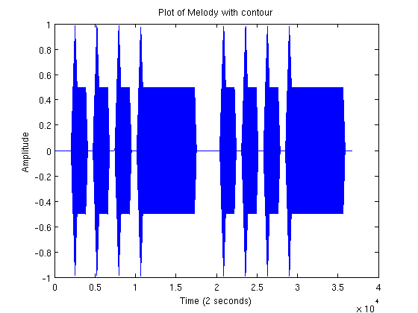

Figure

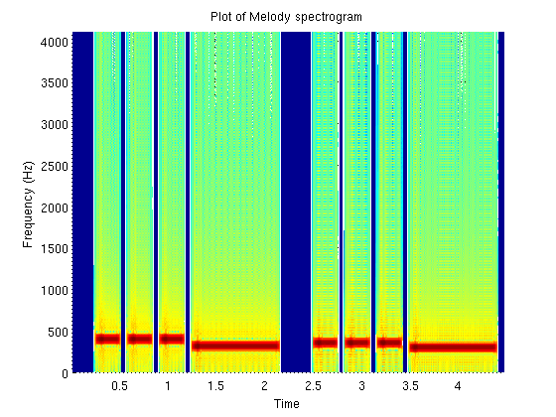

Figure

## Part 3:

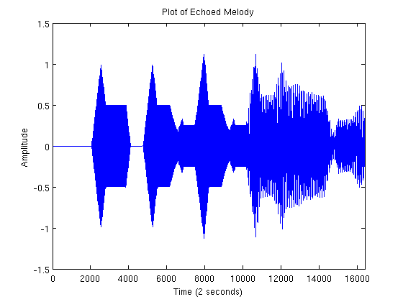

Figure

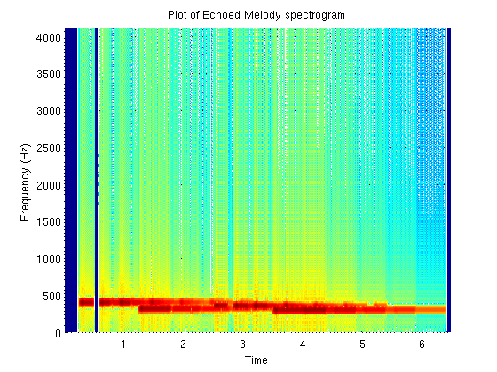

Figure

# Answers to the Questions

[Section by Cullen Fahey]

## Write a mathematical expression for the melody in Part 1. Your answer should be written as an algebraic combination of unit steps and sinusoids and take into account both rests and pauses.

)

## Describe the ways in which the spectrogram of the reverberant melody in Part 3 differs from the original melody in Part 1. Specifically discuss effects of the amplitude and reverberation modifications you made on the spectrogram.

The spectrogram of the reverberant melody in Part 3 differs from the original melody in Part 1 in that the notes overlap in part 3 due to the echo which is part of the reverberation modifications we added. There are slight amplitude decreases throughout the melody in part 3 because as it echoed the echo decreased over time.

## Describe how the modifications in Parts 2 and 3 changed the way the melody sounded. Relate the differences you hear to the amplitude and reverberation modifications you made.

Part 2 changed the way the melody sounded by adding in the attack and decay as well as a sustain and a release and can be seen when comparing figure 5 with figure 11.

Part 3 changed the way the melody sounded by including the changes from part 2 as well as the addition of an echo which can be seen when comparing figure 5 with figure 13 with the overlap of notes.

# Conclusion

[Section by Brandyn Fastino]

This particular project’s goal was to give us a brief introduction to sound generation. Different frequencies were used for each unique note, and its sharp and flat value. Rests were created within the project to separate the notes frequencies from being immediately repeated after each other. With some work, the addition of the rest periods would allow us to change the bpm (beats per minute) of the song. In other words, the notes could be quarters, half our hole notes per second. After the generation of the melody in the particular required timing, we improved the sound quality by breaking up the time segments into each individual system of equations. Concluding our project, a two second long echo was created. This is essential to take into account. Classical music, like our particular melody, is frequently played in concert halls. The reverberation part of this project emphasized this by creating a very simple echo environment.